THE EFFECT OF FOOD ON ADULT BEAN BEETLE (CALLOSOBRUCHUS MACULATES) SURVIVAL: DOES FEEDING INCREASE THE LIFESPAN?

1) Introduction to beetles, & why they are easy to study

Bean Beetles (Callosobruchus maculates) are common agricultural pests found in the tropics and subtropics of both Africa and Asia. Bean beetle larvae feed and develop exclusively inside the seed of legumes (Fabaceae).

They have a rapid life cycle that includes a 10-14 day adult stage. It is currently believed that adult bean beetles do not feed after the larva stage, focusing only on reproduction as an adult. The main purpose of this study was to determine whether food would increase the lifespan of adult bean beetles.

2) Your question

THE EFFECT OF FOOD ON ADULT BEAN BEETLE (CALLOSOBRUCHUS MACULATES) SURVIVAL: DOES FEEDING INCREASE THE LIFESPAN?
3) Details of expt: how you collected virgins, set up, etc.

First, we allowed males and females to mate in a large petri dish full of mung beans. The females laid eggs on the beans. Beans that held the purest white egg(s) were collected and placed individually in 24-well plates, where the bean beetle larvae will grow and hatch from their natal bean as either a virgin male or virgin female. The day that each bean beetle hatched was recorded, and then the main procedure began for that bean beetle. Each bean beetle was randomly designated to one of the 6 experimental food groups as one of the 5 replicates. All of the bean beetles were contained in petri dishes under their specific conditions. Once a bean beetle was added to the experiment, his or her lifespan was observed, recorded, and analyzed.

The experiment was set up with six different food groups, which were labeled as the following: 1) No food (Control group), 2) Fruit fly media, 3) Yeast, 4) Sugar water, 5) Natal bean, and 6) Naked beans. Each group consisted of five Petri dishes, of which contained five replicates of 1 male, 2 males, 1 female, 2 females, and 1 male with 1 female, respectively. (The experimental procedure is expanded and written out in more detail below.)

Project Plan “Experimental Set-up” (Full Detail)

Food Group 1 – Nothing (control group)
Dish 1 – 1 male (5 replicates 1A, 1B, 1C, 1D, 1E)
Dish 2 – 2 males (5 replicates 2A, 2B, 2C, 2D, 2E)
Dish 3 – 1 female (5 replicates 3A, 3B, 3C, 3D, 3E)
Dish 4 – 2 females (5 replicates 4A, 4B, 4C, 4D, 4E)
Dish 5 – 1 male and 1 female (5 replicates 5A, 5B, 5C, 5D, 5E)

Food Group 2 – Fruit Fly Media (soak with water)
Dish 6 – 1 male (5 replicates 6A, 6B, 6C, 6D, 6E)
Dish 7 – 2 males (5 replicates 7A, 7B, 7C, 7D, 7E)
Dish 8 – 1 female (5 replicates 8A, 8B, 8C, 8D, 8E)
Dish 9 – 2 females (5 replicates 9A, 9B, 9C, 9D, 9E)
Dish 10 – 1 male and 1 female (5 replicates 10A, 10B, 10C, 10D, 10E)

Food Group 3 – Yeast (soak with water)
Dish 11 – 1 male (5 replicates 11A, 11B, 11C, 11D, 11E)
Dish 12 – 2 males (5 replicates 12A, 12B, 12C, 12D, 12E)
Dish 13 – 1 female (5 replicates 13A, 13B, 13C, 13D, 13E)
Dish 14 – 2 females (5 replicates 14A, 14B, 14C, 14D, 14E)
Dish 15 – 1 male and 1 female (5 replicates 15A, 15B, 15C, 15D, 15E)

Food Group 4 – Whole Beans
Dish 16 – 1 male (5 replicates 16A, 16B, 16C, 16D, 16E)
Dish 17 – 2 males (5 replicates 17A, 17B, 17C, 17D, 17E)
Dish 18 – 1 female (5 replicates 18A, 18B, 18C, 18D, 18E)
Dish 19 – 2 females (5 replicates 19A, 19B, 19C, 19D, 19E)
Dish 20 – 1 male and 1 female (5 replicates 20A, 20B, 20C, 20D, 20E)

Food Group 5 – Natal Bean
Dish 21 – 1 male (5 replicates 21A, 21B, 21C, 21D, 21E)
Dish 22 – 2 males (5 replicates 22A, 22B, 22C, 22D, 22E)
Dish 23 – 1 female (5 replicates 23A, 23B, 23C, 23D, 23E)
Dish 24 – 2 females (5 replicates 24A, 24B, 24C, 24D, 24E)
Dish 25 – 1 male and 1 female (5 replicates 25A, 25B, 25C, 25D, 25E)

Food Group 6 – Naked Beans (seed coat removed)
Dish 26 – 1 male (5 replicates 26A, 26B, 26C, 26D, 26E)
Dish 27 – 2 males (5 replicates 27A, 27B, 27C, 27D, 27E)
Dish 28 – 1 female (5 replicates 28A, 28B, 28C, 28D, 28E)
Dish 29 – 2 females (5 replicates 29A, 29B, 29C, 29D, 29E)
Dish 30 – 1 male and 1 female (5 replicates 30A, 30B, 30C, 30D, 30E)

4) Raw data: Please see Excel sheet

5) Results
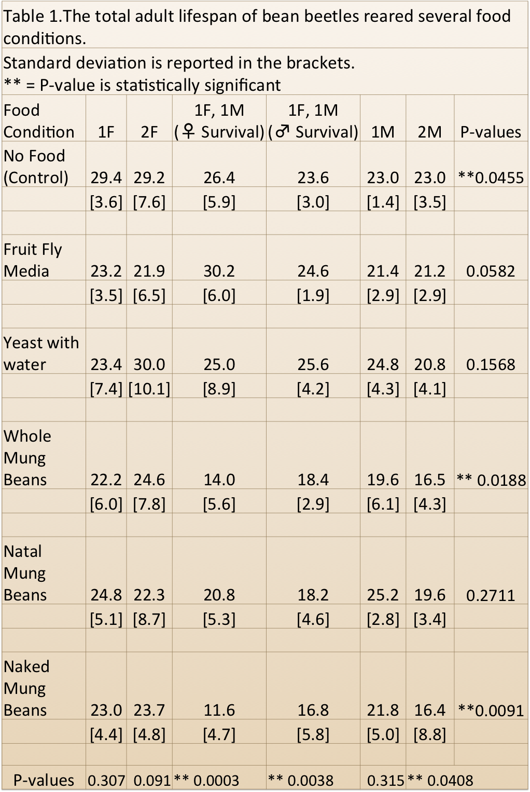

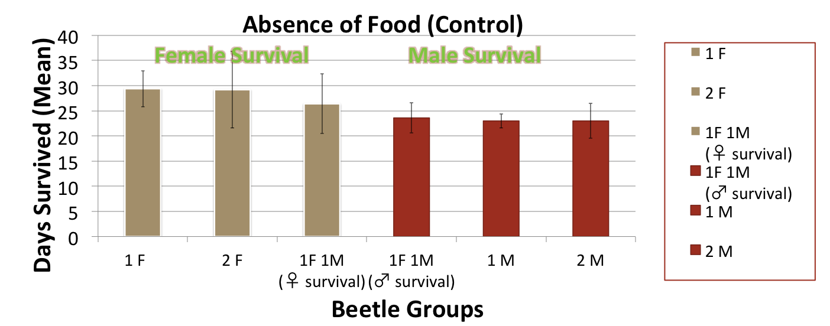

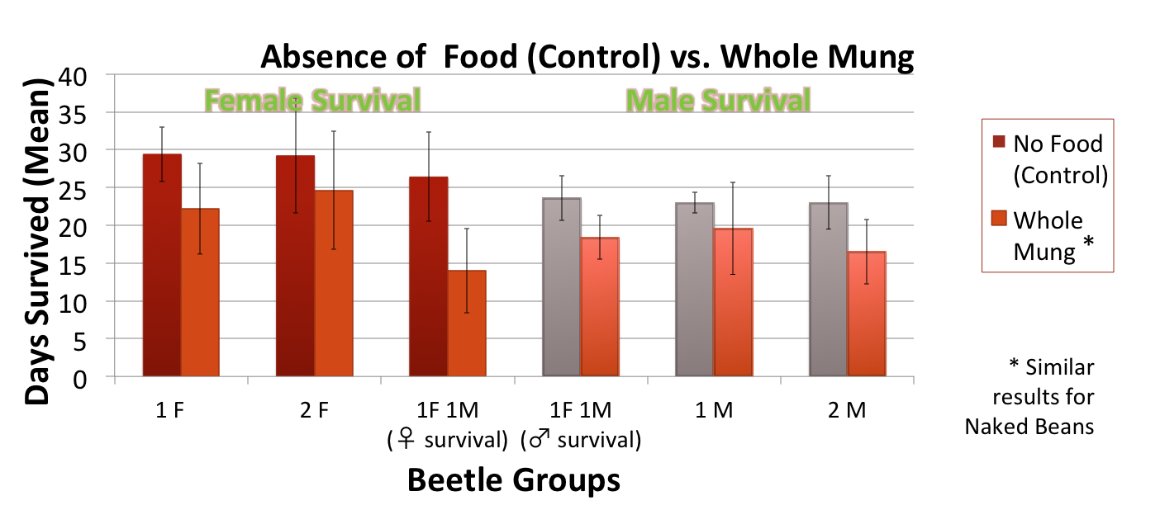

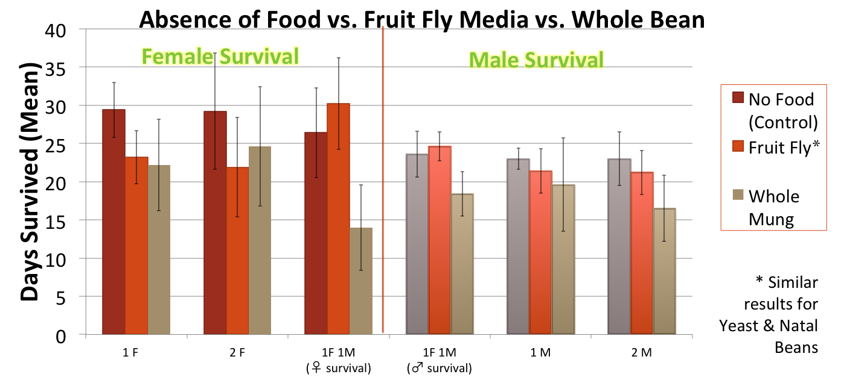

7) Conclusions and future directions
a) Females live longer than males
b) Beetles that mate have a shorter lifespan
c) Beetles raised in Naked beans or Whole mung beans had the lowest survival
d) water-based food types seem to increase life span only when mating
e) Food availability did not increase lifespan

